Fourth Semester Project Synopsis

**VIRTUAL LEARN – ONLINE TRAINING WEBSITE**

Submitted in partial fulfillment of requirement

for the award of the degree

MASTER of COMPUTER APPLICATIONS

of

Visvesvaraya Technological University, Belagavi

By

Deepthi Nayak

4NM20MC021

2020-2022



(An Autonomous Institution affiliated to VTU, Belagavi)

Nitte Mahalinga Adyanthaya Memorial Institute of Technology

Nitte – 574110, Karkala, Udupi District

Fourth Semester Project Synopsis

**VIRTUAL LEARN – ONLINE TRAINING WEBSITE**

Submitted in partial fulfillment of requirement

for the award of the degree

MASTER of COMPUTER APPLICATIONS

of

Visvesvaraya Technological University, Belagavi

By

Deepthi Nayak

4NM20MC021

2020-2022

Under the guidance of

Assoc. Prof Pallavi Shetty

Internal Guide



(An Autonomous Institution affiliated to VTU, Belagavi)

Nitte Mahalinga Adyanthaya Memorial Institute of Technology

Nitte – 574110, Karkala, Udupi District

**ABSTRACT**

Virtual Learning or E-learning fulfils the thirst of knowledge and offers online content that can be delivered for the learner at anywhere, anytime and any age through a wide range of e-learning solution while compared with traditional learning system. It also provides the rapid access to specific knowledge and information. With the rapid growth of voluminous information sources and the time constraint the learning methodology has changed. Learners obtain knowledge through e-Learning systems rather than manually teaching and learning. In this research paper proposes the e-learning management system with web services oriented frame work. This system supports the cross browser and fully integrated with different databases.

E-learning is the use of digital tools for learning. Learning management systems and distance education are among the most prevalent tools. However, hybrid experiences and collaborations are changing the E-learning landscape. Recent developments include the advent of social networking and online learning communities, the ubiquitous presence of smart phones, and an increased recognition of the potential for computer games to transform learning. Other important developments include advances in Intelligent Tutoring Systems, the free Open Educational Resources movement, and the creation of immersive environments allowing users to engage with virtual environments and to digitally augment their experience of the real world.

**TABLE OF CONTENTS**

|  |  |  |
| --- | --- | --- |
| **Sl. No** | **CONTENTS** | **Pg.No** |
| 1 | Introduction | 1 |
| 2 | Literature Survey | 3 |
| 3 | System Study | 6 |
| 4 | System Analysis | 10 |
| 5 | System Design | 11 |
| 6 | Conclusion | 14 |
| 7 | Reference | 15 |

**CHAPTER 1**

**INTRODUCTION**

* 1. **OVERVIEW**

Information Technology has revolutionized the way we go about doing our daily activities. The web for instance has revolutionized the way information can be accessed thereby making the world a global village. The impact of information technology has grown to the level that virtually all domains of life now have everything in electronic. Now we have E-Commerce, E-Examination, E-Voting, E-Registration. The availability and deployment of all of these is made possible with the use of the Internet (the biggest of all the computer networks), a local area network (intranet) for deploying E-Solutions within a restricted locality e.g., an office, telephone lines (using radio wave as its medium).

Of interest also is the advent of information technology enabled devices such as the handsets, the PDAs and tablets that is used with the a fore mentioned web technology which makes the paradigm of information storage, access and retrieval to be mobile.

The Internet is a wide area network consisting of over five hundred million hosts that can be accessed via a workstation that is connected to its service. It serves as a medium of connection between millions of peoples, airlines, organizations, military, educational institutions and government in the most remote of areas all over the world. It serves as an electronic transmission medium to engage in exchanging of information, also aiding transportation (digitally) from location to location connecting users online. Also, the internet is a very good platform for advertisement and awareness of any product.

Information is obviously the most prominent function of the internet. The internet has grown from its inception into a giant warehouse of information, providing millions of people access to any information required by just a click of a button.

It exposes one to a wide range of information resources, thereby posing as a giant database stacked with information. Due to the universal access of the internet, student tutorials and learning activities can be processed over the web. The project work which is focused on modeling and designing an Online Tutorial System through the Web. For the benefits of the students in the university; the online tutorial will include registration of students like their personal information and also made available video and audio type document for downloads, real-time communication between students and tutors. The registration data of the students are stored in a highly secured Relational Database Management System (RDBMS) and the students are provided with a Graphical User Interface (GUI) to communicate with the database.

* 1. **AIMS AND OBJECTIVES**

The aim of this project is to develop an Online Tutorial System for the Students of the university and objectives of this study include:

* To create a system that is user friendly and simple as possible for users.
* To create a system that make available a virtual class that is not limited to any number of students.
* To increase the throughput by increasing the number of students that could participate in a particular tutorial class per unit time.
* To employ the use of internet technology to influence tutorial delivery.
* To design a system that made available videos, audios, images and texts type of documents for learning system.

**1.3 SCOPE OF THE PROJECT**

The scope of this project covers the registration of students' personal information, assign tutorial classes to each student, enable each student to have Real-time conversation with their tutor and colleagues, setting a unique password for confidentiality of personal information such as login menu. The limitation of this project is the unavailability of Real-time video chatting.

**CHAPTER 2**

**LITERATURE SURVEY**

* Despite the enormous growth of e-learning in education and its perceived benefits, the efficiency of such tools will not be fully utilized if the users inclined to not accept and use the system. Therefore, the successful implementation of e-learning tools depends on whether or not the students are willing to adopt and accept the technology. Thus, it has become imperative for practitioners and policy makers to understand the factors affecting the user acceptance of web-based learning systems in order to enhance the students’ learning experience (Tarhini et al., 2014a). However, recent studies have shown that e-learning implementation is not simply a technological solution, but also a process of many different factors such as social factors (Schepers and Wetzels, 2007; Tarhini et al., 2014b; 2015), and individual factors (Liaw and Huang, 2011), organizational such as facilitating conditions (Sun and Zhang, 2006) in addition to behavioural and cultural factors (Masoumi, 2010).Such major factors play an important role in how an information technology is developed and used (Kim and Moore, 2005).
* Fischer et al. (2015) studied how proceedings of scientific conferences can be used for trend studies in the field of e-learning. They examined the abstracts of 427 scientific articles of leading German-speaking e-learning conferences GesellschaftfürMedien in der Wissenschaft and E-Learning-Fachtagungen der GesellschaftfürInformatik e. V. (GMW and DeLFI) – published from 2007 to 2013. The study was conducted at German-speaking conferences and, thus, reflects the situation in Germany, Switzerland and Austria. Fischer et al. (2015) made an important contribution to the diffusion of digital media in higher education. The researchers found that the detailed analysis of the frequency distribution over the seven years reflects the intensity of scientific discussion towards e-learning trends, and conclusions about the didactical or technical potentials of innovations can be introduced. Specifically, they found the development potential of learning management, mobile learning, virtual worlds, e-portfolio, social media and Massive Open Online Courses are crucial for elearning in German higher education.
* Moravec et al. (2015) showed how e-learning tools impact students’ achievement. The study was attended by nearly 2000 students. According to Moravec et al. (2015), the study compares the results of questions from the area of law where the tool was provided in a pilot version with the results of questions, where the e-learning tool was not provided. The researchers found that the e-learning tools have affected the students’ results. Nevertheless, the belief of the e-learning tool may possibly have a negative effect on students who will depend on given materials was disproved.
* By using the Cohen’s model and based on data collected from 15 documents from relevant research studies conducted on the effect of ICT based e-learning on academic achievement during2010-2012, Mothibi (2015) examined the relationship between e-learning and students’ academic achievement in higher education. The researcher found that ICT had a statistically significant positive influence on e-learning based students’ academic achievements. The results also indicated that ICT had a significant positive influence on students’ educational overall academic achievements.
* Scholtzand Kapeso (2014) and Almajali et al (2016), Shannak (2013) explored the factors of mobile learning (m-learning) approaches which can be used for enterprise resource planning (ERP) system. The technology acceptance model (TAM) was applied to assess the acceptance, usefulness and perceived ease of use of the m-learning. The researchers found that the m-learning system was correlated positively for perceived ease of use and perceived usefulness as such findings confirmed other studies which stressed the importance of the quality of course content in e-learning and m-learning projects.
* Pieri and Diamantini (2014) conducted their research based on the experience of e-learning web 2.0 at the University of Milano-Bicocca in the academic year of 2011-2012. The objective of the research was to make the implicit and tacit knowledge that the users have, explicit, and therefore more accessible. Since the ICTs have become an essential part of the learning experience for people all ages, so it’s become a concept that needs to be explored, the researchers started elaborating the transition from Web 2.0 to e-learning and the aggregation of the power of Web 2.0 with social networks in the learning process. They used Thinktag Smart, a new Web 2.0 platform; that mixes the learning opportunities offered by the web 2.0 with the learning opportunities of social networks for sharing knowledge, to train 137 students in two subjects (Tourism, and Sociology of innovation), after this experience they gave them a questionnaire to evaluate the learning experience, and the platform. Thinktag Smart had some features that were most used in the platform: (resources, shelves, and groups); where the least used were: (Wiki, collections and chat), the strengths of the platform which made it generally appreciated, were; the resources or the ability to exchange and share information with users of Thinktag Smart; support teaching as the portal was open to share notes and materials connected to courses they need; and the interactivity feature of the platform provided for the users. As for the weaknesses, which didn’t allow for the complete satisfaction, they were; the slowness in loading the pages, the unclearness/complexity, the lack of immediacy, and intuitiveness. In sum the platform was a tool of great potential, but to be competitive; realities need further improvements.

**CHAPTER 3**

**SYSTEM STUDY**

**3.1 Existing System with limitations:**

The current situation is very limited to few resources, students are unable to get knowledge more than that the lecture provides to them. This in the end limits student’s performances, because everything a student gets is collected from lectures in class.

Here are some of the problems of the current system:

* The current system at Zanzibar University is that lectures download references for students or for lecturing.
* Students submit assignment to lectures through hard copies or personal emails.
* Students only get help from lectures if the lectures are in they’re office.
* New lectures to a course have to get materials on their own.
* Student are required to physical be in the classroom in order to gain knowledge thereby sacrificing all other responsibilities.
* Students are unable to share resources effectively and hold group discussions that are monitored or supervised by lectures

**3.2 The future system**

The system will hopefully serve as a centralized database of syllabus for the courses offered at the university allowing students and faculties (current, past and prospective), to view them. The system will end up bringing an effective communication among students, lectures, and the administration, by accessing information and other resources anytime, anywhere.

Here are some expected results of the project:

* Lectures to upload assignments and resources for their units.
* Students to download the resources and upload assignments.
* It provides an easy-to-use way to manage course websites that include schedule information, announcements, as well as course discussions.

**3.3 OBJECTIVE OF THE PROJECT**

E-Learning represents an innovative shift in the field of learning, providing rapid access to specific knowledge and information. It offers online instruction that can be delivered anytime and anywhere through a wide range of electronic learning solutions such as Web-based courseware, online discussion groups, live virtual classes, video and audio streaming, Web chat, online simulations, and virtual mentoring. E-Learning enables organizations to transcend distance and other organizational gaps by providing a cohesive virtual learning environment. Companies must educate and train vendors, employees, partners, and clients to stay competitive and E-Learning can provide such just-in-time training in a cost-effective way. Developing and deploying effective E- Learning programs may require products and services supplied by a variety of vendors, leaving one to connect the dots. One way to start is to define the goals of the desired learning solution. Definition of the goals of an E-Learning solution is driven by the following factors:

* **To perform task analysis**

Determine the tasks to be taught, identify subtasks and other elements involved, and identify the knowledge, skills, and attitudes required to complete the tasks efficiently and effectively.

* **To perform training needs analysis**

Identify the target audience for the training. Identify the shortfall in knowledge, skills, and attitudes of this audience and determine what the target learners need to know.

* **To review existing capabilities**

Review existing methods and infrastructure for providing training or meeting learning needs.

* **To determine expectations**

Identify concrete expectations and/or ROI requirements from the desired E-Learning solution. The development of an E-Learning strategy begins by setting goals. What will the E-Learning strategy accomplish? Without a true understanding of the goals of the E-Learning strategy, it will be difficult, if not impossible, to be successful.

Before implementing E-Learning, organizations need to set common goals or objectives. Common goals and objectives include the following:

* **To reduce learning costs**

As a small business owner, you know that online transactions cost a fraction as much those requiring paper or staff. It’s the same with E-Learning because there are no papers, no delays, and no travel expenses. Such learning enables employees to take what they have just learned from their computer screens and apply it to the tasks at hand.

* **To motivate employees**

E-Learning is considered an effective way to keep up with new technology, to generate new ideas, and to keep your workforce fresh and inspired.

* **To improve flexibility of course delivery**

Smaller businesses don’t have the staff to manage their training and development initiatives. E- Learning technologies can overcome these administrative restrictions

**3. 4 DEFINITIONS OF (UNFAMILIAR) TERMS**

* **Learning Management System (LMS):-** A Learning Management System (LMS) is a software application or web-based technology used to plan, implement, and assess a specific learning process. Typically, a LMS provides an instructor with a way to create and deliver content, monitor student participation, and assess student performance.
* **Course Management System (CMS):-** A course management system is a set of tools that enables the instructor to create online course content and post it on the Web without having to handle HTML or other programming languages.

##### **3. 5 SIGNIFICANCES OF E-LEARNING SYSTEM**

Technology has the power to transform education. It is essential to bring it into the classroom to empower learning. Here are some of the reasons (significance/importance).

1. Students need to be engaged with what they are doing to improve learning outcomes
2. Enables students to become thinkers/learners/risk takers in a sheltered environment.
3. Learn not to rely on the teacher…be accountable themselves…become independent!
4. Broadens the horizons of many students as it exposes students to the world outside their city or country town.
5. Fits in with Rural Education where students in small rural schools need no longer be disadvantaged by distance and isolation, as technology allows them to learn virtually and maintain their subject choices, allows e.g., LOTE (languages other than English) and other specialist subjects to be taught across schools by a virtual teacher.
6. Allows a mobile learning environment – anywhere, anytime, anyhow.

##### **3.6 STATEMENT OF RESEARCH HYPOTHESIS**

The main goal of this research is to find out about five influential variables derived from previous research were applied as independent variables, while perceived e-Learner satisfaction was used as a dependent variable.

* **Hypothesis 1**. Learner attitude toward computers will positively influence perceived e- Learner satisfaction with e-Learning.
* **Hypothesis 2**. Learner computer anxiety will negatively influence perceived e-Learner satisfaction with e-Learning.
* **Hypothesis 3**. E-Learning course flexibility will positively influence perceived e-Learner satisfaction with e-Learning.
* **Hypothesis 4**. E-Learning course quality will positively influence perceived e-Learner satisfaction with e-Learning.
* **Hypothesis 5.** Technology quality will positively influence perceived e-Learner satisfaction with e-Learning.

**CHAPTER 4**

**SYSTEM ANALYSIS**

**4.1 REQUIREMENT SPECIFICATIONS**

**4.1.1 HARDWARE REQUIREMENTS**

* i3 processor
* 2GB RAM
* 128 SSD
* Other operating System

**4.1.2 SOFTWARE REQUIREMENTS**

* Chrome or any other web Browsers
* Visual Studio

**4.1.3 SKILLS**

* React js
* Node js

**CHAPTER 5**

**SYSTEM DESIGN**

**5.1 DATA FLOW DIAGRAM**

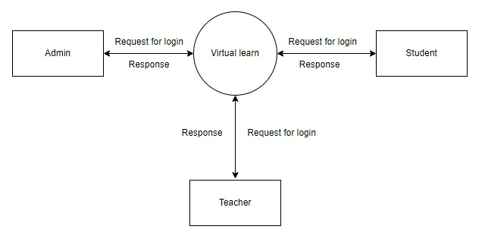

**5.2 MODULE DESCRIPTION**

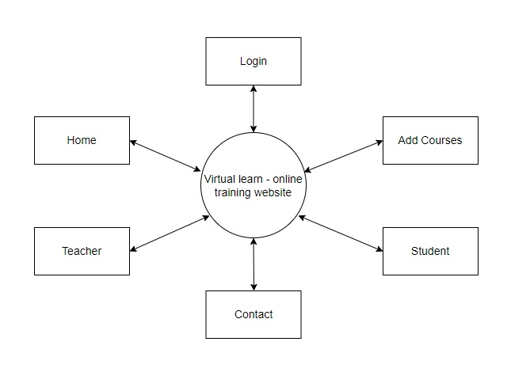

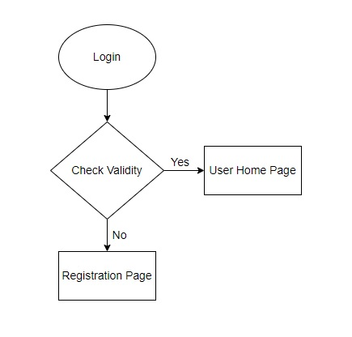

**5.3 USE CASE DIAGRAM**

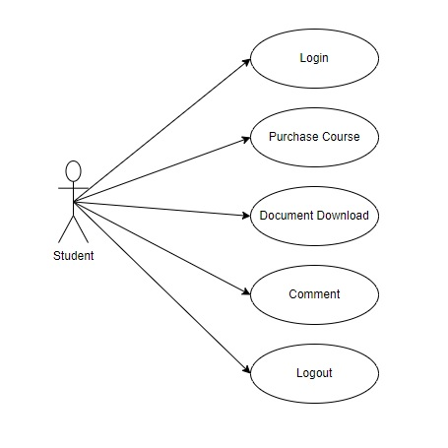

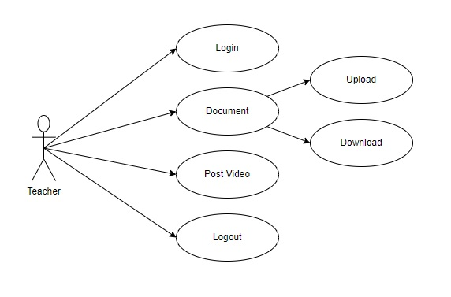

**5.4 SEQUENCE DIAGRAM**

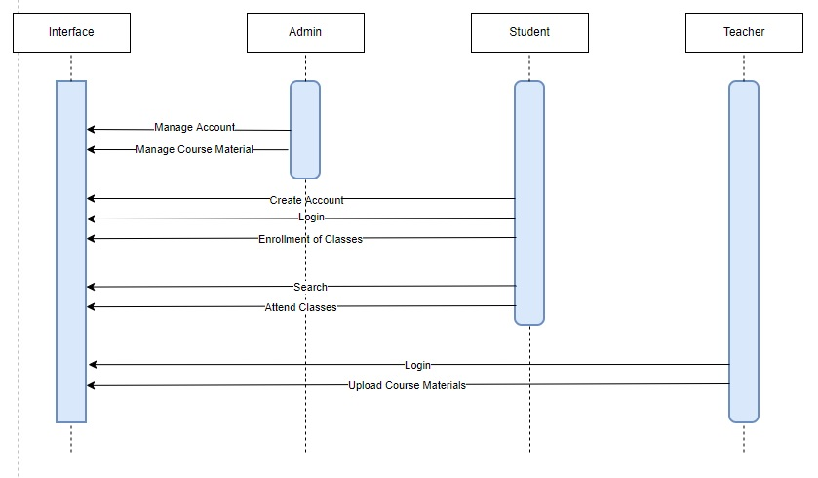

**CHAPTER 6**

**CONCLUSION**

This paper critically reviewed the literature related to e-learning systems and identified some of the most influential factors used in the field of information systems research. More specifically, this paper had an insight on the origins, characteristics as well as the limitations, weaknesses and strengths of web-based learning systems. Student variables, such as behaviours and attitudes, cultural backgrounds and other demographic characteristics are important variables that influence student learning, especially in a collaborative e-learning environment. Understanding these variables is now helpful for instructors to design meaningful educational activities to promote student knowledge construction and make learning more effective and appealing. In particular, this research helps to better understand the characteristics of students in Lebanon and England respectively, which can help policy makers, educators and experts to understand what the students expect from the learning management systems. This can help the management achieve the most effective deployment of such system and also helps them improve their strategic decision making about technology in the future, they can decide on the best approach that fit their students before implementing any new technology

**CHAPTER 7**

**REFERENCES**

* Abbasi, M. S., Elyas, T., & Shah, F. (2015). Impact of individualism and collectivism over the individual’s technology acceptance behaviour: A multi-group analysis between Pakistan and Turkey. Journal of Enterprise Information Management, 28 (6), 747-768
* Abbasi, M.S., Hassouna, M. & Shah, F. (2015). Social, Organizational, Demography and Individuals’ Technology Acceptance Behaviour: A Conceptual Model. European Scientific Journal, 11 (9), 48-76.
* Al-Dmour, R., Obeidat, B., & Almajali, D. (2015). The Practice of HRIS Applications in Business Organizations in Jordan: An Empirical Study. Proceedings of the 4th Scientific & Research Conference on New Trends in Business, Management and Social Sciences (COES&RJ-TK15/1), Istanbul, Turkey, 19-20th September, 53-74.
* Alenezi, A., & Shahi, K. (2015). Interactive E-Learning through Second Life with Blackboard Technology. Procedia Social and Behavioural Sciences, 176, 891-897.
* Alenezi, H., Tarhini, A., & Masa’deh, R. (2015). Investigating the Strategic Relationship between Information Quality and E-Government Benefits: A Literature Review. International Review of Social Sciences and Humanities, 9 (1), 33- 50.
* Alkalha, Z., Al-Zu’bi, Z., Al-Dmour, H., & Alshurideh, M. (2012). Investigating the Effects of Human Resource Policies on Organizational Performance: An Empirical Study on Commercial Banks Operating in Jordan. European Journal of Economics, Finance and Administrative Sciences, 51, 44-64.
* Almajali, D., & Al-Lozi, M. (2016). Determinants of the Actual Use of E-Learning Systems: An Empirical Study on Zarqa University in Jordan. Journal of Social Sciences, 5 (2), 1-29.
* Almajali, D. A. Masa'deh, R., & Al-Dmour, R. (2016). The Role of Information Technology in Motivating Students to Accept E-Learning Adoption in Universities: A Case Study in Jordanian Universities. Journal of Business & Management (COES&RJ-JBM), 4 (1), 36-46.
* Almajali, D. A., Masa’deh, R., & Tarhini, A. (2016). Antecedents of ERP Systems Implementation Success: A Study on Jordanian Healthcare Sector. Journal of Enterprise Information Management, 29 (4), 549-565.